Background Notes for Parents/Carers

About the theme – Local Church

After Christmas children will explore the theme of Local Church, which is our story. The parish is where people gather together to celebrate and practise care and love for each other. The diocese is the community of the Christian faithful. The Local Church theme focuses on the people of God, gathered in Christ, united in the journey of faith, in care for one another, in sharing their story and in celebration.
The experience of community is an essential and enjoyable part of life for people of every age and faith. The cycle of a year and the span of a lifetime contain occasions for regular celebrations as well as unexpected surprises, when people want to celebrate with family, friends and communities.
The Church’s celebrations are also community occasions. On Sundays, the parish family gathers together. It is a time to remember how much there is to celebrate; a time to say thank you; a time to know that God’s love is offered and made visible here and now in Jesus and in people. Sacraments are more formal special moments: signs of ‘God-with-us’, who journeys with his people; signs of strength and blessing for life.

YEAR 3 – COMMUNITY

Throughout this topic, your child will progressively learn about the Christian family’s journey with Jesus. They begin with looking at special events in their lives and then begin to reveal important events in the Church’s calendar. You will look at how events mark the journey through the seasons of the year. In addition, how we can help one in life’s journey?

Key Vocabulary | YEAR 3  Journeys  LOCAL CHURCH THEME  The Christian life is about journeying with Christ and sharing his way of life. The Church’s year celebrates the key elements of Christ’s life.  Children will know and understand:  • a journey through a year  • the Christian family’s journey with Jesus through the Church’s year  See Background Notes for Parents and Carers  Week 1: Look at the cycle for the year. Discuss different events you would normally attend throughout the year. Look at a liturgical year together and discuss special events and seasons in this.  Week 2: Focusing on the special events in the Liturgical calendar, explain that the calendar focuses on the Church’s family journey with Jesus through the major events of his life, death and resurrection.  Week 3: Share a selection of psalms together (see below) Talk about what a pilgrimage is and why people go on a pilgrimage.  Week 4: Look at the key vocabulary for this topic and use it to remember all we have learnt about Journeys.  Celebrate with a simple Act of Worship (see below).
calendar
seasons
journey
liturgical
ordinary time
feast day
psalm
pilgrimage
Temple
Overview

Year 3
In Year 3 the children learn about the journey through a year, its calendar of events, celebrations and seasons. They will learn that the liturgical calendar of the Church’s year is made up of seasons, including feasts, and that prayer is an important part of a Christian’s journey through the year.
Week 1: Talk about the celebrations during the Christmas holiday. What events marked this time? What customs does each family have for Christmas and the New Year? Think about the whole year, the school terms and the events at school and in the family. Note Bank Holidays (holidays for all), family birthdays, family holidays, seasons and special days e.g. Mother’s Day, Father’s Day, Valentine’s Day, Bonfire Night and how these are usually celebrated. (This year has been different because of Covid19 restrictions.) Think also about the difficult or sad events of the year, seasonal difficulties, the good byes to friends etc.
Questions to discuss:
What makes the journey through the year good?
What makes the journey through a year difficult? Discuss how this year has been more difficult because of lockdown etc.
If you were going on an actual journey, who would you like as a companion?
How would you travel?
What would you take with you?
What would be your reasons for these choices?
Task: Paint the year, using different colours for the seasons, which reflect the mood of that season. If you do not have paint, use coloured pencils, pens or crayons.
Look at the diagram of the Liturgical Year (Shown below). The year of the Church family is marked by special events and seasons. It is called the Liturgical Year. It begins with the first Sunday of Advent and ends with the feast of Christ the King. The word liturgical means the Church family’s celebration and remembrance of the journey of Jesus when he lived on earth, his death and Resurrection. It is a calendar of Sundays, feast days and special seasons, which are celebrated during one year. A feast day is a day set aside by the Church family to celebrate an event in the life of Jesus, Mary his mother or a saint.
Liturgy is the actions and words of the prayer and worship the Church family offers to God.
The Liturgical Year helps Christians to be close to the work of the Trinity, God the Father, Son and Holy Spirit, throughout the seasons of the year. It brings the Church family together as everyone shares in the celebrations. Following the celebrations, Christians are sent out to love and serve God in the world.
- How is the Church’s year marked?
- When does it begin and end? Why do you think it happens like this?
- What do you notice about the colour used at different times?

Task: Design a Liturgical calendar (see below for template) that accurately represents the Church’s year using signs, symbols and colours to denote the different seasons and feasts

Week 2: The first Sunday of the Liturgical Year is the first Sunday of Advent. The last Sunday of the Liturgical Year celebrates the feast of Our Lord Jesus Christ, King of the Universe. The Church family journeys with Jesus through the major events of his life, death and Resurrection. Here is an outline of special seasons in the Liturgical Year.
Advent – Christmas
- The Season of Advent is the four Sundays before the 25th December; the colour the Church uses is purple.
- The Season of Christmas time: from the Nativity of the Lord, (Christmas Day) to the Baptism of the Lord. The colour the Church uses is white or gold.
Major feasts during Christmas time:
- The feast of the Holy Family, Jesus, Mary and Joseph.
- The feast of Mary the Mother of God (1st January).
- The feast of the Epiphany of the Lord (6th January).
- The Baptism of the Lord.
Lent – Easter
- The Season of Lent: forty days from Ash Wednesday (five Sundays). The colour the Church uses is purple.
- Holy Week: begins with the Sixth Sunday of Lent: Palm Sunday of the Passion of the Lord (sometimes called Palm Sunday).
- The Sacred Easter Triduum: begins with the evening celebration of Holy Thursday and includes Good Friday and Holy Saturday.
- The Season of Easter time: begins with the Easter Vigil, Easter Sunday and for seven Sundays to Pentecost. The colour the Church uses is white or gold. On Pentecost Sunday the Church uses the colour red.

- What times of Jesus’ life are being celebrated in these seasons?
- Which of the seasons or feasts is your favourite and why?
- What do think the colours tell us about these seasons?

Task: Choose some of the events mentioned and in a text, explain to a friend how the Church family journeys with Jesus throughout the year. Could you try making links with the major events of his life such as; Death and Resurrection?

Week 3: Jesus would have gone to the synagogue, every week on the Sabbath (Shabbat). He would have listened to readings from the Scriptures and sung psalms. On three special occasions each year, it is possible he would have journeyed to the Temple in Jerusalem to celebrate the feasts that highlight the Jewish Year. As the people travelled along, they often sang to keep themselves cheerful and pass the time, but each day, at particular times, they sang their prayers in preparation for the feast they were going to celebrate. These ‘song-prayers’ are called psalms and we still sing these Jewish prayers today. Perhaps you can try to remember the next time you say or sing a psalm (at Mass, for instance) that these psalms are the very same prayers that Jesus himself used to pray. There were particular psalms that people used on the way to feasts in Jerusalem, they were called foot psalms or pilgrimage psalms, as they were said as people went on foot to Jerusalem. There were particular psalms for each stage of the journey, looking forward to the moment when they would catch sight of the beautiful Temple as they came over the hill.
One particular psalm expressed the great joy of the pilgrim standing inside the Temple in God’s presence:
‘I rejoiced when I heard them say: “Let us go to God’s house”.
And now our feet are standing within your gates, O Jerusalem.’
Psalm 122
Use God’s Story 3 pages 42-43 for other pilgrimage psalms (See below)

- Are there any songs you sing when you are travelling with the school or your family?
- How do you think the Jewish people felt when they first saw the Temple in Jerusalem? Remember they didn’t have televisions or cameras in those days, so they would not know what it would look like until they saw it.
- What do you think the journey was like in Jesus’ time? Why do you think it would help to sing the psalms?

Task: Write your own psalm for a journey to a special place of worship.

Week 4:
Look at the key vocabulary for this topic and use it to remember all we have learnt about Journeys. Celebrate with a simple Act of Worship. (see below)

Resources
Week 1
Example of four seasons painting:

The Seasons of the Year

Week 2
Template for the Liturgical Year

Text to a friend, explaining how the Church family journeys with Jesus throughout the year
Week 3

Week 3:

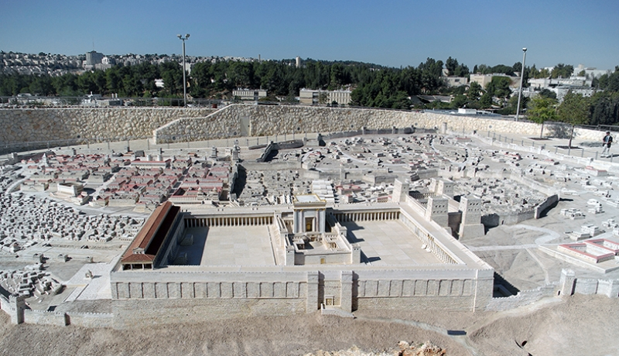
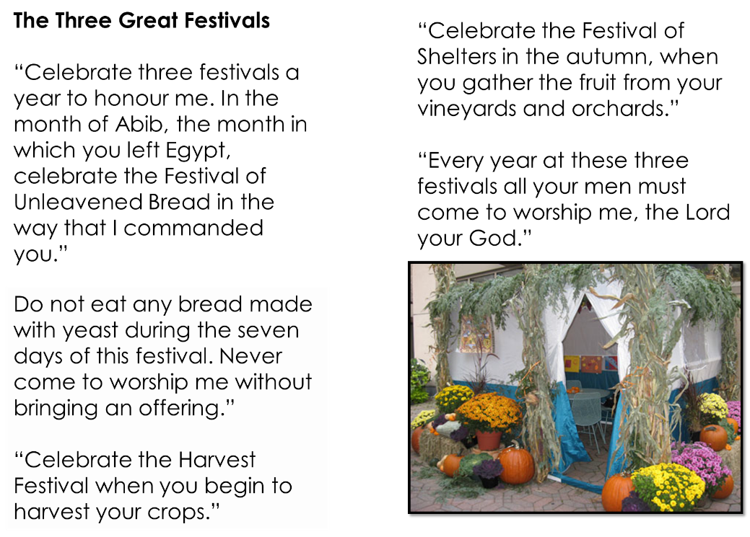

Week 4
Act of Worship
JOURNEYS
Year 3
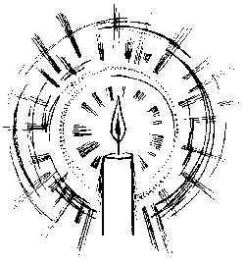
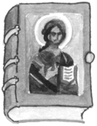
“God is with us on our journey”
Gathering
together
You might like to set up a Focus table with some of the following:
Calendar, Liturgical calendar (from the internet),a Bible if possible.

We have been looking at all the journeys we make in our lives and we’ve been
reflecting upon life, the whole of our lives, as a long journey. As we start our liturgy let us gather In the name of the Father and of the Son and of the Holy Spirit Amen.
The idea of life as a journey for the people of God is repeated over and over again in the Bible. The Bible has many stories of journeys in both the Old and New Testaments. The Jewish people in Jesus’ time journeyed to the Temple in Jerusalem to celebrate important feasts. When people make a special religious journey this is called a pilgrimage. The special song-prayers the Jewish people sang on the way to Jerusalem were called pilgrimage psalms.
Let’s listen to this reading from Psalm 122 which tells us how happy the pilgrims were when they reached the Temple.

A reading from the Book of Psalms
The Word
of God

I was full of joy when they said to me,
Let us go up to God’s house.
And now we are standing
inside the gates of Jerusalem.
Jerusalem is a great city, the city of peace.
The people of Israel come here to give thanks to God.

The Word of the Lord.
Thanks be to God
Response

Let us reflect in silence for a moment on the journeys we have made, including the journey of our life, and thank God for being with us each step of the way.

Let us say a litany in response to the word: The response is God is with us

When we set out on a journey God is with us
When the way ahead seems difficult God is with us
Through times of quiet prayer God is with us
Through times of celebrating together God is with us
On our journey through life God is with us

{you might like to invite your child to add their own prayers, or you could add a family focussed prayer to the litany}

Leader
Going forth
Sit and think quietly about how we can invite God to be with us as we journey through our lives.

In the name of the Father and of the Son and of the Holy Spirit Amen.

