Phonics in Nursery
During your child’s time in Nursery we will be preparing them for their future education by equipping them with the skills they will need for science, maths, writing and reading among many others.
Early reading in Nursery begins with teaching your child how to listen effectively. This will then enable them to hear different sounds and eventually recognise sounds in words. This is all taught through fun and exciting activities with the children learning through play. We teach from the government phonics program ‘Letters and Sounds’ and primarily focus on Phase 1 and Phase 2.
Phase 1 includes 7 aspects:

Aspect 1 - General sound discrimination – environmental

The aim of this aspect is to raise children's awareness of the sounds around them and to develop their listening skills. Activities suggested in the guidance include going on a listening walk, drumming on different items outside and comparing the sounds, playing a sounds lotto game and making shakers.

Aspect 2 - General sound discrimination - instrumental sounds
This aspect aims to develop children's awareness of sounds made by various instruments and noise makers. Activities include comparing and matching sound makers, playing instruments alongside a story and making loud and quiet sounds.

Aspect 3 - General sound discrimination - body percussion
The aim of this aspect is to develop children's awareness of sounds and rhythms. Activities include singing songs and action rhymes, listening to music and developing a sounds vocabulary.

Aspect 4 - Rhythm and rhyme
This aspect aims to develop children's appreciation and experiences of rhythm and rhyme in speech. Activities include rhyming stories, rhyming bingo, clapping out the syllables in words and odd one out.

Aspect 5 - Alliteration
The focus is on initial sounds of words, with activities including I-Spy type games and matching objects which begin with the same sound.

Aspect 6 - Voice sounds
The aim is to distinguish between different vocal sounds and to begin oral blending and segmenting. Activities include Metal Mike, where children feed pictures of objects into a toy robot's mouth and the teacher sounds out the name of the object in a robot voice - /c/-/u/-/p/ cup, with the children joining in.

Aspect 7 - Oral blending and segmenting
In this aspect, the main aim is to develop oral blending and segmenting skills.To practise oral blending, the teacher could say some sounds, such as /c/-/u/-/p/ and see whether the children can pick out a cup from a group of objects. For segmenting practise, the teacher could hold up an object such as a sock and ask the children which sounds they can hear in the word sock.
The activities introduced in Phase 1 are intended to continue throughout the following phases, as lots of practice is needed before children will become confident in their phonic knowledge and skills.
These aspects are all things which you can work on at home to support your child’s reading and writing.
Alphabet and letter recognition
In nursery we primarily talk about the sounds the letters make rather than their name which is taught as the alphabet. So instead of saying apple begins with A (ay) we say that the words initial sound is a. To help the children remember how to write and say these letter sounds (phonemes) we use the rhymes from the RWI phonics program.
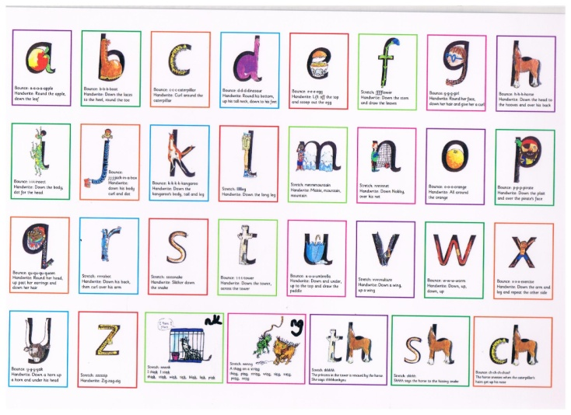
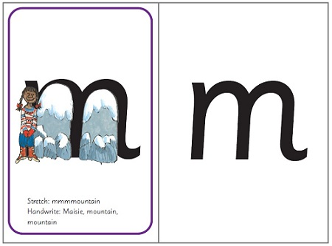
Children all develop at different rates and some develop their listening skills later than others. Do not worry if your child is initially unable to hear the first sound in words. Theses skills take a lot of practice and repetition which is why it is essential for you to support what your child does in Nursery, at home. If we feel your child would benefit from some extra support with their speaking and listening skills we will talk to you privately to advise you on what support would be best for your child.
Above all we want reading and writing to be fun for children and our aim is to develop a love of books and communication. One of the best things you can do to help develop your child’s skills is to share a book with your child on a daily basis, discussing the characters and pictures and asking them questions about what has happened in the story.
We are always available to discuss any aspects of your child’s education and are happy to give you ideas of how to support them throughout their time at St Joseph’s Nursery.
The Nursery Team

Helpful websites
www.letters-and-sounds.com
Google Letters and sounds DFES and you will get the link below
https://www.gov.uk/government/uploads/system/uploads/attachment_data/file/190599/Letters_and_Sounds_-_DFES-00281-2007.pdf
https://www.topmarks.co.uk/english-games/3-5-years/letters-and-sounds
https://www.teachyourmonstertoread.com/
http://www.ruthmiskin.com/en/resources/sound-pronunciation-guide/



