Times | Monday | Tuesday | Wednesday | Thursday | Friday
9:00-9:30 | Registration  Link to be sent just before 9  Let’s get moving: Click here | Today is funny hair day !!  How crazy can you make your hair?  Registration  Link to be sent just before 9  Let’s get moving: Click here | Registration  Link to be sent just before 9  Let’s get moving: Click here  Joe wicks morning P.E | Funny hat day !!  Please wear a funny hat to registration  Registration  Link to be sent just before 9  Let’s get moving: Click here | Registration  Link to be sent just before 9  Let’s get moving: Click here  Jo Wicks Morning P.E
9:30-10:00 | Let’s start the week off with getting moving!  P.E Lesson: Jasmin account login.  Pirate adventure.  Please click on the ‘Pirate and follow the directions’ | Billy goats costume party!  Can you either cut out or make your own characters. From the Three Billy Goats Gruff story. Have them ready for tomorrow lunch time | Lesson:  Live news report  Click here  Why was the troll so sad ?  Why do you think he didn’t want anyone to go over the bridge ?  How would you feel ? | Run, Run as fast as you can you can’t catch me…. I am the ginger bread man.  Click here. | Ginger bread man baking activity.  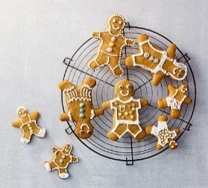
10:00-10:30 | Break time:  Time to go outside and get some fresh air and healthy snack. | Break time:  Time to go outside and get some fresh air and healthy snack. | Break time:  Time to go outside and get some fresh air and healthy snack. | Break time:  Time to go outside and get some fresh air and healthy snack. | Break time:  Time to go outside and get some fresh air and healthy snack.
10:30-11:15 | Billy goats’ gruff letter.  Click here.  We have received a letter from the billy goats gruff. Can you help them make a Bridge.  A letter from the billy goats, can we help ?  Can you use different materials to make a bridge?  What materials did you use?  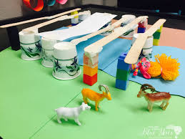  Was it strong? DID you test it ? | Humpty Dumpty  Science experiment.  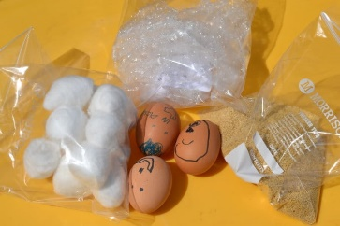  (click here for more details)  Have the prediction form ready (learning resources) | Phonics time.  Listening and guessing game.  The fairies have been back in nursery and would like to know what the names of these objects are can we help them ?  Click here for link.  Now it’s your turn, can you sit with your grown up and describe an object from your magic bag. | Maths  Maths meeting  Magic number 10  Click here.  Number hunt ( Resource pack )  Write the number 1-10 on different pieces of paper, hide them around the house. Have your child find the numbers then lay them in order.  Take a number away and see if they can guess which one you have taken. | Maths  Ginger bread man maths game  Click here  Maths Meeting
11:15-12:00 | Purple Mash.  Work booklet.  Maths Meeting.  Magic number 8 | Phonics :  This week we are looking at the different sounds letters make. Today is ‘M’  Click here  Continue to work Rhyming words  and syllables. | Live billy goats Gruff lunch party.  11:30 a link will be sent for all children to participate in a live lunch. We can all dress up and have our lunch together.  Please make sure your mic is muted. We will all have a chance to talk | Phonics :  ‘A’a  Click Link.  Rhyming syllables. | P.E lesson :  Jasmin log in account.  Lets get working on our balancing skills.
12:00-1:00 | Lunch | Lunch | Lunch | Lunch | Lunch
1:00-2:00 | Rhyming game  Find the rhyme ( Find the rhyme in activity pack )  Our grown ups have been so busy so lets help them out, here are a few challenges for you guys to do. Please take pictures and show me how help full you are  1-Make your bed.  2-Help sort out the washing.  3-Help your grown up do the  Dishes  4-Help cook dinner. | Purple mash  Work booklet  Maths Meeting  Pairs number game  Click here  (This is a little bit tricky guys, give it a go ) | Maths  Over the next few weeks, we will be looking at patterns.  What is a repeating pattern?  Click here | Ginger bread man.  Design challenge.  Can you design the best ginger bread man that has ever existed?  (learning resources pack) | Ginger Bread man home learning challenge  ( Resource pack)  Can you re-tell the story of the ginger bread man.  What other character would you use/ choose.
2:00-3:00 | Story Time.  Traditional Stories come from all over the world.  Let’s have a look at one from: Africa  Why the sun and the moon live in the sky  Click here | Traditional Polish Nursery Rhyme.  Let’s have a go at learning a new nursery rhyme in Polish  Click here  What’s your favourite Nursery rhyme?  Can you act it out or draw a picture about it ? | Purple Mash  Online learning pack  FOLLOW THE BEAT  CLICK HERE | R.E  Celebrations.  Click here.  We are going to plan a welcome back to school celebration party.  Can you make an invitation for the party ? | Yet another week over . You guys are Amazing, fantastic, super stars.  Here is a challenge …. Can you find the beat in Mrs Halligans favourite song.  Dress up in your favourite costume and try and find the beat in this song (Photos and videos are welcomed.  Click here

