Background Notes for Parents/Carers

About the theme – Eucharist
In the Spring term the Sacrament of the Eucharist is explored. This is the Sacrament of communion with Christ and the Church.
There are several different names given to the Sacrament of the Eucharist. It is called:
- Eucharist: (Thanksgiving) because it is an action of thanksgiving to God. It reminds us of the thanks that Jesus made to his Father at the Last Supper.
- The Lord’s Supper: because of its connection with the supper which the Lord took with his disciples on the eve of his Passion.
- The Breaking of Bread: because Jesus used this rite, part of a Jewish meal, when as master of the table he blessed and distributed the bread, above all at the Last Supper. It is by this action that his disciples will recognise him after his Resurrection.
- The memorial of the Lord’s Passion and Resurrection.
- The Holy Sacrifice: because it makes present the one sacrifice of Christ the Saviour and includes the Church’s offering.
- Holy Communion: because by this sacrament we unite ourselves to Christ who makes us sharers in his Body and Blood and to one another to form a single body.
- Holy Mass, (Missa) because the liturgy concludes with the sending forth (missio) of the faithful, so that they may fulfil God’s will in their daily lives.

Children are introduced to a different aspect of the Eucharist, the Mass, in each year group.

Structure of the Mass
The Basic Structure of the Mass has four parts: two main parts (the Liturgy of the Word and the Liturgy of the Eucharist) and two framing rites (Opening Rite and Concluding Rite):

Introductory or Opening Rites: WE GATHER
We lead those gathered into an awareness of God’s presence who has assembled a community of faith.
Procession and song
Sign of the Cross
Greeting
Penitential Rite (when we say sorry to God)
(Gloria) – a song of praise used on Sundays and feast days
Opening Prayer or Collect

Liturgy of the Word: WE LISTEN
We listen and respond to the Readings and the Homily.
First Reading (from the Old or New Testament)
Responsorial Psalm (a Psalm from the Old Testament)
(Second Reading – included on Sundays) (from the New Testament)
Gospel Acclamation ( to prepare to greet the Gospel)
The Gospel (from Matthew, Mark, Luke or John)
Homily (a short address by the bishop, priest or deacon)
(Creed – included on Sundays) – a profession of faith
Prayer of the Faithful (bringing our prayers for different needs before God)

Liturgy of the Eucharist: WE GIVE THANKS
We offer bread and wine and all that we have.
Preparation of the altar and the gifts (the bread and wine)
Eucharist Prayer (including the words of Jesus and prayer of consecration)
Communion Rite:
Lord’s Prayer (the Our Father)
Sign of Peace (offering a gesture of peace to others)
Breaking of the Bread
Communion (distribution of the Body and Blood of Christ)

Concluding Rite: WE GO OUT
Blessing
Dismissal (sending out)

Key Vocabulary | YEAR 3  Listening and Sharing  EUCHARIST THEME  The Eucharistic celebration consists of two parts. The first part is the Liturgy of the Word, where Christians listen to God’s Word in the readings, listen to the homily and the prayers of the Faithful. The second part of the celebration is the Liturgy of the Eucharist. Here the gifts are prepared, the Eucharistic prayer expresses thanksgiving and Communion is shared.  Children will know and understand:  • Listening and sharing with one another  • Listening to the Word of God and sharing in Holy Communion  See Background Notes for Parents and Carers  Week 1: Talk about the importance of listening and sharing. Share a story and ask your child to retell it.  Look at how people gather at church and the Introductory Rite. Talk about your own experiences of church and what happens in your church. Practice making the sign of the cross (if appropriate). Ask your child to design a guide to the beginning of Mass.  Week 2: Read about the Liturgy of the Word, the readings and responses. After the Liturgy of the Word comes the Liturgy of the Eucharist. Talk about what happens during the Liturgy of the Eucharist at the offering of Gifts. How do we live out ‘giving of ourselves to God and one another’?  Week 3: Read or watch a recorded Mass online, focussing on the words and actions of the priest in the Eucharistic Prayer.  Look at the Communion Rite. Share the Our Father prayer and look at what happens at the end of Mass. Design a poster representing people being sent out after Mass.  Week 4: Look at the key vocabulary for this topic and use it to remember all we have learnt about Listening and Sharing.  Celebrate with a simple Act of Worship (see below).
listening
sharing
Eucharist
Mass
gathering
Liturgy of the Word
Liturgy of the Eucharist
Holy Communion
Good News
ambo
Overview
Year 3
In Year 3 the children will focus on the different parts of the Mass and some of the prayers said during Mass.
If possible try to watch an online Mass e.g. St Mary’s Cathedral live streamed every week day at 12.05pm or you can watch a previous day’s recording: https://www.youtube.com/channel/UC12EvW0Eqg-cFTh5i2y_EQw
A printed Mass sheet will help children to follow the service (for weekday Masses the Gloria and the Creed are omitted): http://www.liturgyoffice.org.uk/Missal/Text/MCFL.pdf
Week 1:
Lesson 1: Talk about the importance of listening: share any experiences of what happens when you didn’t listen.
- What did you miss when you didn’t listen?
- What happens when people don’t listen to you?
- How do you feel when you know you are listened to?
Tell the story of Stone Soup (see below). Talk about the importance of sharing.
Task: Retell the story of Stone Soup. If you listened carefully you should be able to remember lots of details. Share the story with your family.

Lesson 2: On Sunday, members of the parish family come together to share the Sacrament of the Eucharist. Welcomers greet the people as they come into the church and give them the books they need. The musicians get their music ready. The altar servers and the priest put on their vestments. When the time comes to begin Mass, someone rings a bell, and everyone stands up to sing the Gathering Hymn. The servers then come in followed by the priest. This is the beginning of the Introductory Rite. Rite means the action of God’s people, ceremony or act.
The priest and people make the Sign of the Cross as the priest says, “In the name of the Father and of the Son and of the Holy Spirit.” and the people respond, “Amen!” He welcomes the parish family using the words, “The Lord be with you.” Everyone replies, “And with your spirit.”
This reminds us of the ending of the second letter of Paul to Timothy, this is what he says:
‘The Lord be with your spirit. God’s grace be with you all.’ 2 Timothy 4: 22
- Why do members of the parish family come together on a Sunday?
- How do the people prepare for Mass?
- What happens during the gathering?
- What do you think Paul’s words to Timothy mean?
Task: Role-play the different parts of the gathering: Procession, the Sign of the Cross and welcome. Using the images from Church’s Story 3 page 54 write a short guide describing and giving reasons for some of the things which happen when people gather to celebrate Mass.
Week 2:
Lesson 1: During the Liturgy of the Word, the readings proclaim the message of God’s love and truth, mercy and forgiveness as it has been told by the People of God in the Old and New Testaments. On Sunday at Mass there are three readings.
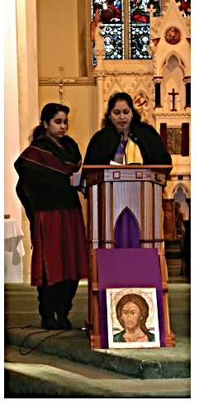
When the Gospel is proclaimed, there are a few differences to show how important this reading is. It is read by the priest or the deacon, if there is one present. Everyone stands and joins in the singing of the Gospel Acclamation. Often two altar servers with lighted candles will stand either side of the lectern, called the ambo.

The first reading is usually from the Old Testament. It is followed by a Responsorial Psalm. The second reading is usually from one of the letters in the New Testament. At the end of each reading the reader says, “The Word of the Lord.” And everyone replies, “Thanks be to God.” Members of the parish family will read these readings, and everyone sits and listens during this time.

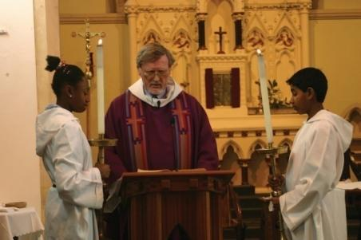
The priest or deacon makes the Sign of the Cross on the page of the Gospels, his forehead, lips and heart. The people also make the Sign of the Cross on their foreheads, lips and heart, in preparation to hear the Good News of the Gospel of Jesus Christ. We make the Sign of the Cross on our foreheads to show we believe in God’s Word, on our lips to show we try to speak God’s Word to others, and on our hearts to show we love God’s Word and will try to live a good life.
Christians believe that God speaks through the Scriptures and that the Gospel is the Good News. Watch an online Mass and listen and watch carefully as the Gospel is being read.
- What is the Liturgy of the Word?
- Why does God speak to us through the Scriptures?
- Why is it important to listen?
- Why do you think there is a difference in the way the Gospel is proclaimed and who reads it?
- What preparation do people make to hear the Gospel? What do you think this means?
- In what ways is the Gospel ‘Good News’ for the followers of Jesus?
Task: Draw the three small crosses on the template below and give reasons for the actions.
Lesson 2: At the end of the Liturgy of the Word, the priest and people together say the Creed, which is a statement of what they believe. It starts with the words ‘I believe in one God’. The second part of the Mass now begins. It is called the Liturgy of the Eucharist.
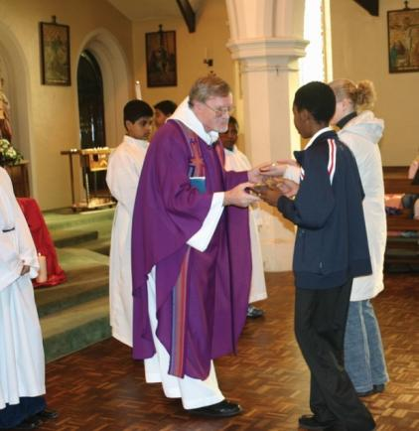
Now members of the parish family carry the bread and wine up to the altar from the table at the back of the Church. The collection is taken and brought up to the altar with the gifts. All these gifts represent the giving of ourselves to God and one another
Once the priest has received the gifts of bread and wine he stands at the altar and offers these to God and praises God for providing them.
The priest holds up the bread and says:
“Blessed are you, Lord, God of all creation for through your
goodness we have received the bread we offer you:
fruit of the earth and work of human hands.
It will become for us the bread of life.”
The parish family join in with this blessing and say: “Blessed be God for ever.”
He holds up the wine and says:
“Blessed are you, Lord, God of all creation for through your
goodness we have received the wine we offer you:
fruit of the vine and work of human hands.
It will become our spiritual drink.”
The parish family join in with this blessing and say: “Blessed be God for ever.”
The cup is called a chalice. The dish, which contains the hosts, is called a paten.
- What gifts are brought in procession to the altar?
- Who brings the gifts to the altar?
- Who receives the gifts?
- What does the priest do with the gifts?
- What do the gifts of bread and wine represent?
Task: All these gifts represent the ‘giving of ourselves to God and one another’. How and why do we live this out in our daily lives? ( e.g. collecting for the local food bank/CAFOD because we are sharing food or what we have with others in need as Jesus showed us.) Can you link this to any scripture you have read? Use the worksheet below.
Week 3:
Lesson 1: The Eucharistic Prayer gives thanks for all God’s goodness. The greatest of all gifts is Jesus and in this prayer the Church remembers the special meal of the Last Supper. This is a time when the priest speaks the words of the prayer and the parish family listen carefully and pray quietly in their hearts. Holding the host, the priest says the words Jesus used at the Last Supper:
“Take this, all of you and eat of it; for this is my Body, which will be given up for you.”
(Jesus’ words mean ‘This is my living presence today, this is myself, this is me’.)

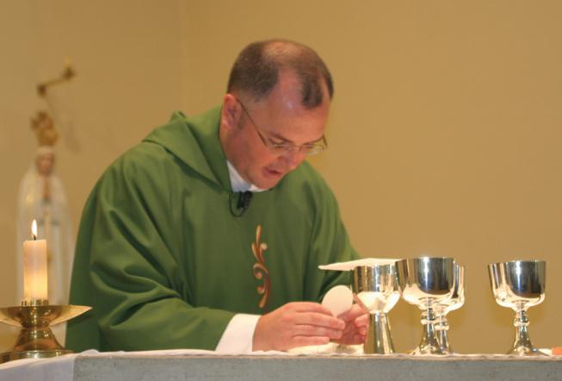
Holding the chalice, the priest says,
“Take this, all of you and drink from it;
For this is the chalice of my Blood,
the Blood of the new and eternal covenant.
which will be poured out for you and for many for the forgiveness of sins,
Do this in memory of me.”
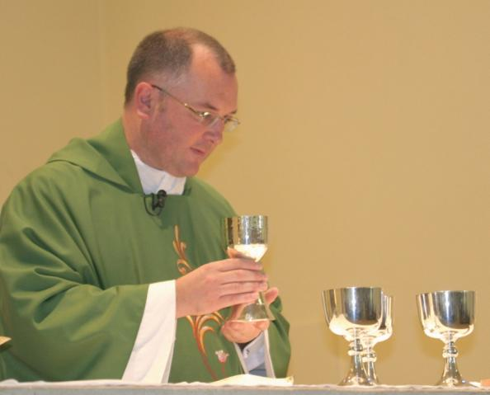
By the power of the Holy Spirit the bread and wine have now become the Body and Blood of Jesus. At the very end of the Eucharist Prayer everyone says ‘Amen!’, which is a Hebrew word. It means ‘let it be so’, ‘we agree’.
[Bread and wine was part of the staple diet of people at the time of Jesus.
New eternal covenant can be explained to children in this year group as Jesus being with us in the past, the present and in the future.]
- What kind of prayer is the Eucharistic Prayer? (Thanksgiving)
- When we celebrate the Eucharist, what are we thanking God for?
- What links the Eucharistic Prayer to the Last Supper?
- What did Jesus mean when he said, “This is my body”?
- Why do you think Jesus chose bread and wine as symbols to remember him by?
Task: If you are able to watch a recorded Mass online freeze frame at significant points giving children an opportunity to ask and respond to questions, describing what is happening, who is involved, what they are doing and why. If you don’t have access to a recording try acting out the actions of the Eucharistic Prayer.

Lesson 2: The Christian family comes to the Lord’s table united in love of Jesus and one another. Communion with Jesus is celebrated in prayers and actions. If you can watch an online Mass children would be able to follow this more easily.
Firstly, everyone prays the Our Father, the prayer which Jesus gave his friends. Then the priest prays for peace and then he says,
“Peace be with you” and people respond: “And with your spirit.”
Before COVID restrictions the people used to share a Sign of Peace with each other before sharing Holy Communion. Although the parish family are no longer able to shake hands with each other they do pray for peace at this point.
Everyone prays or sings the prayer; ‘Lamb of God…’.
The priest invites people to come to Communion. He holds up the sacred host and chalice and says,
“Behold the Lamb of God, behold him who takes away the sins of the world.
Blessed are those called to the supper of the Lamb.”
The people respond by saying,
“Lord I am not worthy that you should enter under my roof, but only say the word and my soul shall be healed.”
The priest receives the Body and Blood of Christ, (Holy Communion) and gives Communion to the Extraordinary Ministers of Holy Communion and servers. Then the people come in procession to receive Communion. The priest or Extraordinary Ministers of Holy Communion hold up the host to each person saying, “The Body of Christ.”
They used to do the same with the chalice saying, “The Blood of Christ.” and the person responded, “Amen!” But because of COVID restrictions only the host is given at present at Mass.
In receiving Holy Communion, the people are nourished by the Body and Blood of Christ. They become what they have received. This is a quiet time when people pray, thanking God for the gift of sharing Jesus in Holy Communion.
At the very end of Mass, the priest blesses the people and he or the deacon sends them out to share God’s love with others.
[Rite means the action of God’s people, ceremony or act.
Sacred host: the host is made of unleavened bread (without yeast) ‘sacred’ means ‘holy’ because it has become the Body of Christ.
Extraordinary Ministers of Holy Communion: women and men who are specially appointed to help the priest to give Communion. They will also take communion to people who are sick or housebound.]
- What happens during the Communion Rite?
- What gestures or signs and prayers are important in the Communion Rite (Sign of Peace, Lamb of God, holding up the Host and Chalice, giving and receiving)
- Praying for peace and unity is part of the Communion Rite. What helps us to be peaceful within ourselves and with one another?
- What is the difference between the bread and wine brought up during the Preparation of the Gifts and what is received at the Communion Rite?
- What do Catholics believe is happening when they receive Holy Communion?
Task: Can you make a poster with footprints on it, representing the people being sent forth from Mass. On each footprint write a word or phrase indicating how they could share God’s love. You can use the footprint template to help you or create your own.
Week 4:
Look at the key vocabulary for this topic and use it to remember all we have learnt about Listening and Sharing. Celebrate with a simple Act of Worship. (see below).

Resources
Week 1 Lesson 1 Stone Soup
One day, a poor man was walking along when he came to a village. As he approached it, the villagers thought, ‘Here is a beggar and we don’t have much ourselves’. They started going towards their homes, hoping he would go away, and they would not have to share anything.
The man called out that he was hoping for somewhere to sleep and a meal. The villagers told him to go away and that they had not got enough to eat themselves. The man told them he had everything for a meal and that he was thinking of making stone soup for everyone. He took a stone out of his pocket and an iron cooking pot out of his bag.

He started to build a fire and fill the pot with water. He put his stone into the boiling water. The villagers came out of their houses and watched as the man sniffed the contents of the pot and licked his lips. “That is good,” he said, “it just needs a pinch of salt and some parsley.”
“I can give you some,” a villager responded, and she returned with parsley, salt and a cabbage.

“Thank you,” remarked the man, “I once had stone soup with cabbage and some carrots
and it was really delicious.” Then another villager said, “Well, as it happens, I do have a few carrots.” He returned with some carrots and a turnip. So, it went on until there were potatoes, onions and mushrooms. Someone even had some loaves of bread.

When it was ready everyone sat down and enjoyed a really lovely soup. There was enough
for the entire village. When the man left the next morning, one of the villagers, stopped him and said, “I would like to buy your magic stone. You have given us the greatest of gifts the secret of how to make soup from stones. We shall never forget.” The man replied. “The stone is not the greatest gift, but sharing is. It is only by sharing that we may make a feast.”

- What do you think of the villagers?
- Why were they afraid to let the man into their homes?
- What started the sharing?
- What lesson did the villagers learn?
- What is the cost of sharing?
- What are the joys of sharing?

Week 1 Lesson 2 Church’s Story 3 page 54
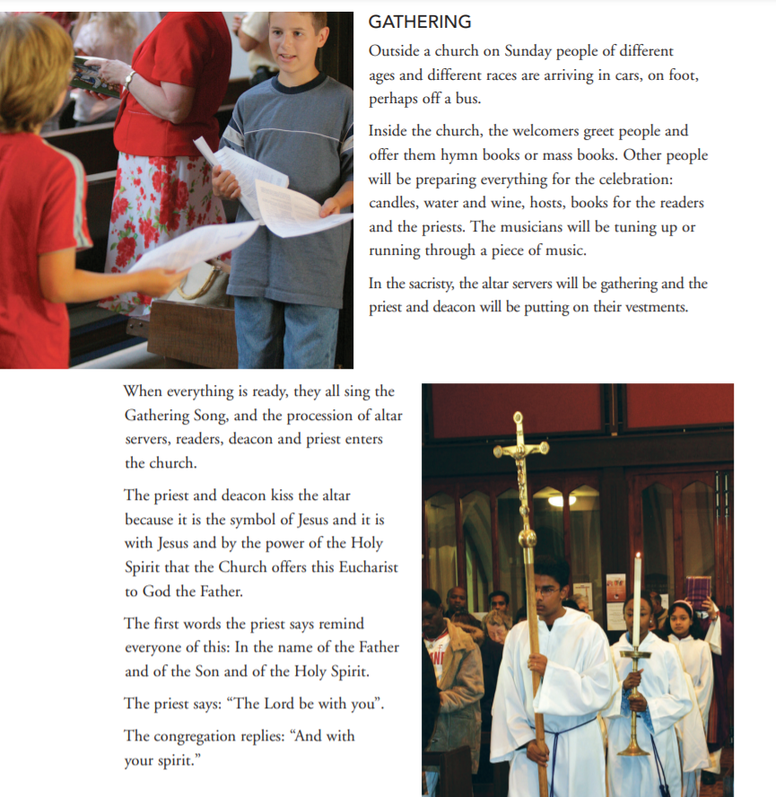

Week 2 Lesson 1 Task
Draw the three small crosses on the template below and give reasons for the actions.
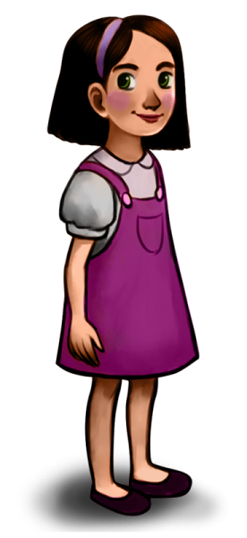
We get ready to listen to the Gospel by singing Alleluia and by tracing a sign of the cross with our thumb three times, first on our forehead, then on our mouth, then over our heart:
on our forehead: as we ask that the Word of God may stay in our minds and our thoughts
on our mouth: as we ask that our words and actions may stay on our lips
over our heart: as we ask that the Word of God may stay in our hearts

Week 2 Lesson 2 Task
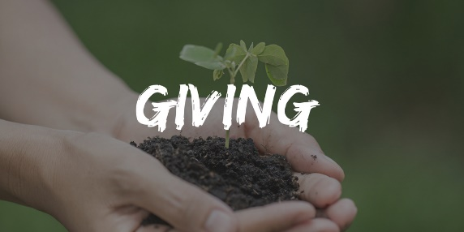
All these gifts represent the ‘giving of ourselves to God and one another’. How and why do we live this out in our daily lives? ( e.g. collecting for the local food bank/CAFOD because we are sharing food and what we have with others in need as Jesus showed us.) Can you link this to any scripture you know?
________________________________________________________________________________________________________________________________________________________________________________________________________________________________________________________________________________________________________________________________________________________________________________________________________________________________________________________________________________________________________________________________________________________________________________________________Week 3 Lesson 2 Task
Can you draw a picture of a how you live out this quote in your daily life?
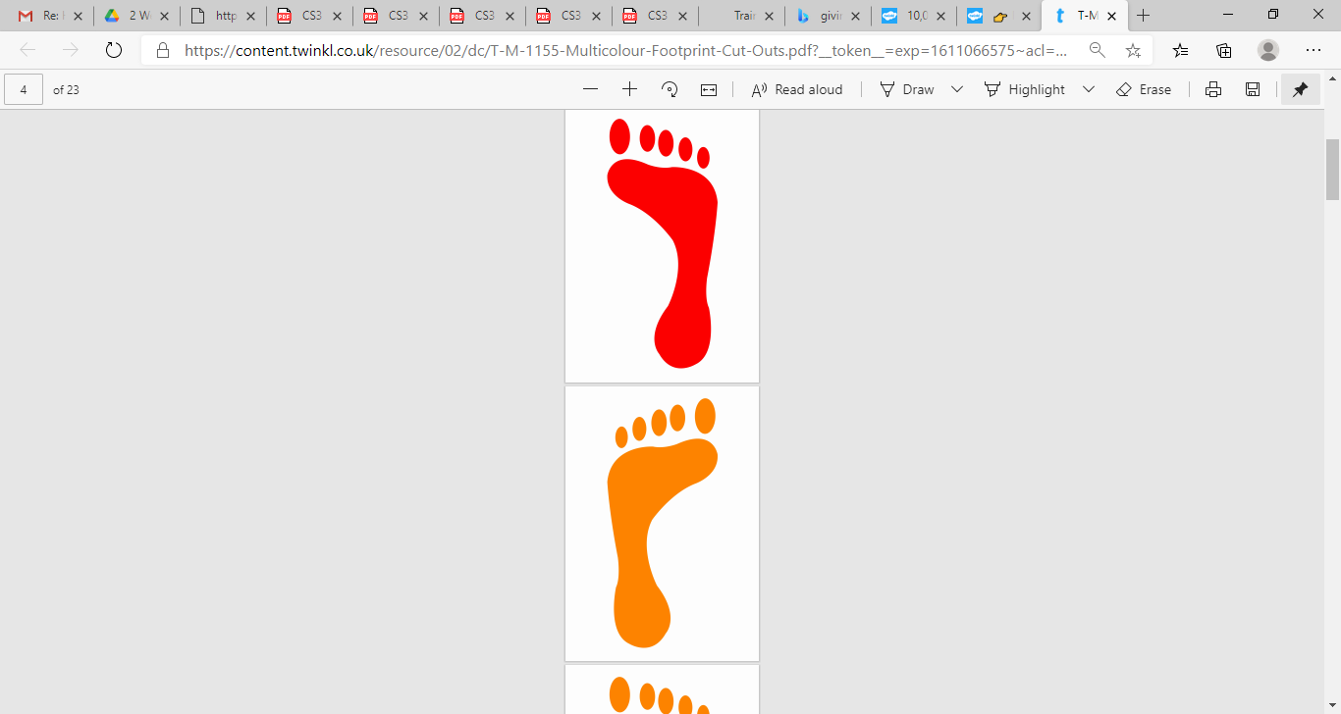

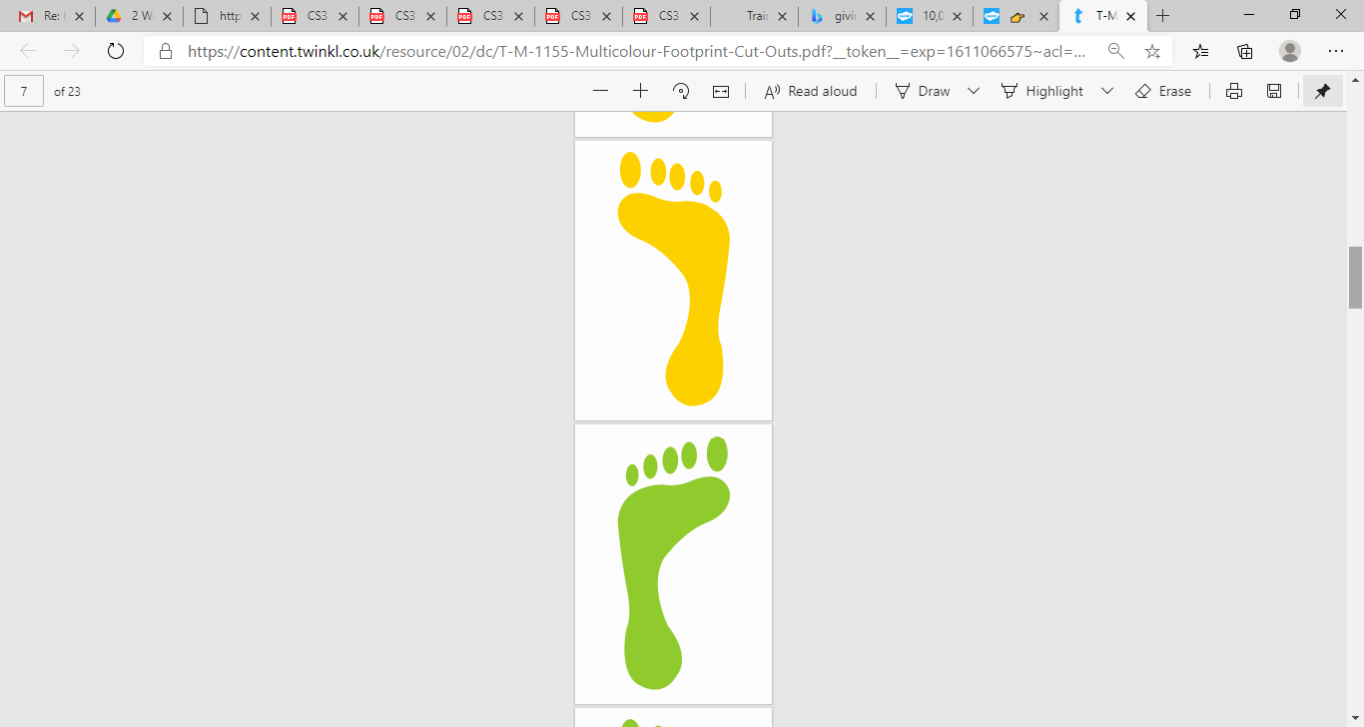

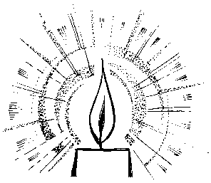
Week 4
Act of Worship
‘LISTENING AND SHARING’
Year 3
‘Jesus gives himself to us in a special way’
Gathering
Together

You might like to set up a Focal table with some of the following:
Candle, Bible (if possible), some of your child’s work on Listening and Sharing.

We say together
In the name of the Father and of the Son and of the Holy Spirit. Amen

The Lord be with you
And with your Spirit

We have been learning about how St Paul used these words when he was greeting the early Christian communities. The priest now uses these words to greet the parish family when they gather together to celebrate Mass. We have also been thinking about the importance of listening and sharing in our lives.

Christians believe that God speaks through the Scriptures and that the Gospel is Good news. Let us now listen carefully to the Gospel and try to hear what God is saying to us. Ask yourself - ‘what is God saying to me in this story?’
The Word
of God
A reading from the Holy Gospel according to St Luke
Glory to You, O Lord

We make the sign of the cross on our forehead, lips and heart, in preparation to hear the Good News of the Gospel. We make the sign of the cross on our foreheads to show we believe in God’s Word, on our lips to show we try to speak God’s Word to others, and on our hearts to show we love God’s Word and will try to live a good life.

Jesus, filled with the Holy Spirit, returned to Galilee. News about him spread all through that place. He taught in the synagogues and everyone praised him.
He came to Nazareth where he had been brought up and went into the synagogue as he usually did. He stood up to read. He was given the scroll of the prophet Isaiah. He unrolled the scroll and found the place and read:
“The Spirit of the Lord is upon me for he has chosen and anointed me to bring good news to the poor, to heal the broken hearted. He has sent me to set free all those who are imprisoned or oppressed in any way.”
He rolled up the scroll, gave it back to the synagogue attendant and sat down. All the people in the synagogue were looking at him as he said to them,
“This passage of Scripture came true today while you heard it being read.”
Everyone was impressed by him and marvelled at the wonderful and powerful words that he spoke.

The Gospel of the Lord
Praise to You Lord, Jesus Christ.

Response to
the Word
We have learned about the importance of listening to God’s Word. What do you think God was saying to you in the Gospel story?

God shares the gift of Jesus with us especially in Holy Communion. But whenever people gather together to pray Jesus shares his presence with them. Jesus also shared a special prayer with his friends. We say this prayer before Holy Communion in the Mass and we think of it as our family prayer.
Let us now share that prayer together…
Our Father
Who art in heaven,
hallowed be Thy name;
Thy kingdom come;
Thy will be done on earth as it is in heaven.
Give us this day our daily bread;
and forgive us our trespasses
as we forgive those who trespass against us;
and lead us not into temptation,
but deliver us from evil. Amen

Going
Forth
As we end our act of worship let us think about how we might share God’s love at home, or in the playground and in the classroom.

Let us share the sign of peace with one another.

In the name of the Father and of the Son and of the Holy Spirit. Amen



