Three Little Pigs Crafts – Materials:
- 3 TP Rolls for the three little pigs
- 1 Kitchen Towel Roll for the big bad wolf
- Paint
- Googly eyes
- Felt leftovers
- Glue
- Paper & pens for the pigs’ simple paper origami houses

Three Little Pigs TP Rolls Craft – How To:
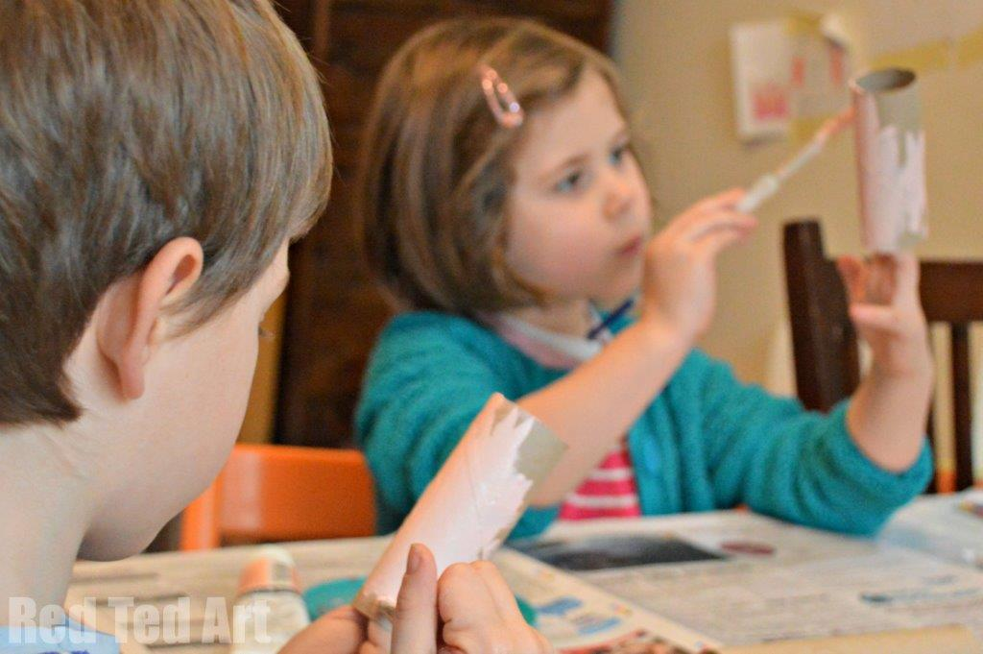
1) First I got the kids to help me paint the toilet rolls – 3 in little pig colours and one in a black big bad wolf.
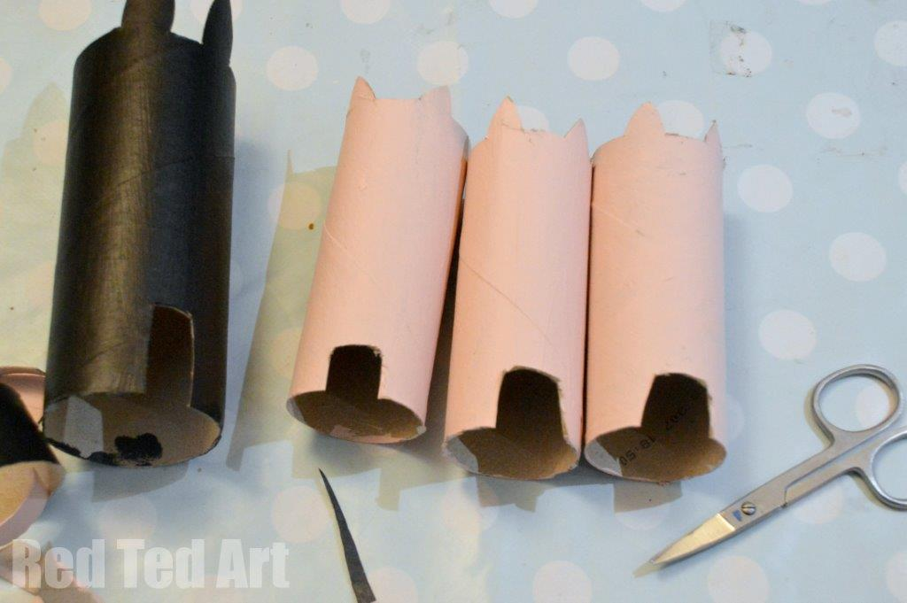
2) Once dried, using a pair of nail scissors, I cut out “features” – with that I mean, I cut down the top the toilet roll to make the ears and cut a slot at the bottom to make the feet. I fiddled with the wolf for ages to get him right. At one point he looked like a rabbit and not a big bad wolf about to huff and puff your house down! The key to the wolf, I think was cutting a flap out of the centre and “lifting it up” to make a snout. I attached paper teeth and think that had the right effect!
3) Then we stuck on googly eyes, felt snouts (you can draw these on) and some felt dungarees (again you could draw these on, use fabric scraps or coloured paper). The big bad wolf also got some hair ears and eye brows.

