Background Notes for Parents/Carers

About the theme – Local Church

After Christmas children will explore the theme of Local Church, which is our story. The parish is where people gather together to celebrate and practise care and love for each other. The diocese is the community of the Christian faithful. The Local Church theme focuses on the people of God, gathered in Christ, united in the journey of faith, in care for one another, in sharing their story and in celebration.
The experience of community is an essential and enjoyable part of life for people of every age and faith. The cycle of a year and the span of a lifetime contain occasions for regular celebrations as well as unexpected surprises, when people want to celebrate with family, friends and communities.
The Church’s celebrations are also community occasions. On Sundays, the parish family gathers together. It is a time to remember how much there is to celebrate; a time to say thank you; a time to know that God’s love is offered and made visible here and now in Jesus and in people. Sacraments are more formal special moments: signs of ‘God-with-us’, who journeys with his people; signs of strength and blessing for life.

Key Vocabulary | YEAR 5  Mission  LOCAL CHURCH THEME  The Church, the Christian family, is made up of smaller Christian families called dioceses. Each diocese is led by a bishop. The bishops continue the work of ‘the twelve’, the apostles, who continued the work and mission of Jesus. Jesus is the head of these families. He is the head of the Church. There are other Christian families which are not part of the Catholic Church. Ecumenism is the word used for promoting unity among Christian churches. One of the final prayers of Jesus was that all Christian families might be one.  Children know and understand:  • The mission of inspirational leaders  • Dioceses continue the work and mission of Jesus including ecumenism  See Background Notes for Parents and Carers  Week 1: Talk about mission as a particular vocation in life – something that God has called you to do.  Consider the quote from Blessed John Henry Newman to consider your own mission.  Use the template to create an action plan to begin your own charity.  Week 2: Research the Diocese of Hexham and Newcastle to find out key facts about the role it plays in society.  Create a response to the letter from Bishop Robert – consider how he inspires, supports and shapes the lives of the people in the diocese.  Week 3: Look at Church’s Story 3 page 7 and discuss what it means. Introduce ecumenism as a movement towards Christian Unity.  Spend some time researching other Christian denominations (Methodist, Baptist, Anglicans and Pentecostal) – when did the denomination begin? Who leads them? What do they believe?  Write a prayer for Christian Unity using scripture and what you know about Christian beliefs.  Week 4: Look at the key vocabulary for this topic and use it to remember all we have learnt about Mission.  Celebrate with a simple Act of Worship (see below).
Mission
bishop
ecumenism
cathedral
diocese
inspirational
Baptism
Christian Unity
inspired
denominations
Overview

Year 5
In Year 5 the children learn how some people are inspirational in their mission to do great things. They learn that Jesus’ mission was to bring ‘Good News’. Our diocese (local family of parishes) and Bishop continue Christ’s work and mission today.
Week 1: Discuss what the word ‘inspirational’ means? What does the word ‘community’ mean? What is a ‘mission’? Ask your child if they know anyone who has a mission? What do these people believe and why? How do they show what they believe when doing their job?
Saint John Henry Newman wrote some famous lines about everyone having a special task in life, it may seem to be ordinary and simple, but if it is done in love for God and our neighbour, it is a definite task or mission which is special to each person:
God has created me
To do Him some definite service.
He has committed some work to me
Which he has not committed to another.
I have my mission.

Complete the action plan below to create your own charity.

Week 2:

Read God’s Story 3 page 95, Luke 4: 14-22. Jesus begins his mission. Discuss the way that Jesus was able to fulfil his mission, through the twelve apostles who shared his mission. Consider the way that continues today, through priests and lay people who continue to share the mission of Jesus.
Explain that parish families form part of larger Christian communities called dioceses. Discuss where your local diocese is in relation to the rest of England and Wales.
Explain that the Bishop leads the diocese in a Church called a Cathedral. This is where the bishop, as leader of the Christian community in the diocese, has his seat and celebrates Mass. The name Cathedral comes from the Greek word ‘Cathedra’ meaning chair or seat (Further information about the Bishop is attached).
Use the internet to find out:
-the name of the diocese
-the name of the leader of the diocese
-the name of the cathedral and where it is
-how the diocese helps the local community

Read the letter from Bishop Robert and respond to him. Consider how he tries to inspire, support and shape the lives of people in our diocese.
(Please note: letter has been slightly adapted due to Easter content – full letter can be found: http://www.rcdhn.org.uk/bishop_rb/pdfdoc/2020/Pastoral%20Letter%20Holy%20Week%202020.pdf)

Week 3: Read God’s Story 3 page 109 Jesus’ prayer for his friends (based on John 17: 11-12; 20-23) and the reading based on: 1 Corinthians 12: 12-17, 21, 27 – see below. Discuss how they talk about what Jesus wanted for his friends and how he wanted us to treat our neighbours.
Explain that until about 1530 the Church in England and Wales was Catholic. Then came a time of change in the world. People were beginning to have new ideas about what it meant to be a Christian. There were many arguments about religion. Many people split away from the Catholic Church because they wanted to reform it and were called reformers. A number of different Christian Churches were created.
In more recent times, Christians have tried to re-unite the Churches by emphasising what they have in common and not their differences. The Churches are united through Jesus Christ and made one by the Holy Spirit. Through the Sacrament of Baptism, all Christians are called to share Jesus’ mission, but Christians carry it out in different ways.
All Christians are journeying towards God and towards unity, remembering Jesus’ words that ‘they may all be one.’ This movement towards Christian unity is called ecumenism and all Christians have a responsibility through prayer and discussion to carry out Christ’s commandment to ‘love one another’. We do this through spreading the Good News and promoting justice and peace in the world in which we live. In January each year a Week of Prayer for Christian Unity is said throughout the dioceses.
Spend some time researching other Christian denominations (Methodist, Baptist, Anglicans and Pentecostal) – when did the denomination begin? Who leads them? What do they believe?
Write a prayer for Christian Unity using scripture and what you know about Christian beliefs.
Week 4: Look at the key vocabulary for this topic and use it to remember all we have learnt about Mission.
Celebrate with a simple Act of Worship (see below)

Resources
Week 1
MY CHARITY ACTION PLAN
Name of your charity:
What is your aim?
Who was your inspiration?
What will you do?
How will this help them?
What demands would you have?

What joys would it bring to others?
What joys would it bring to you?

Week 2

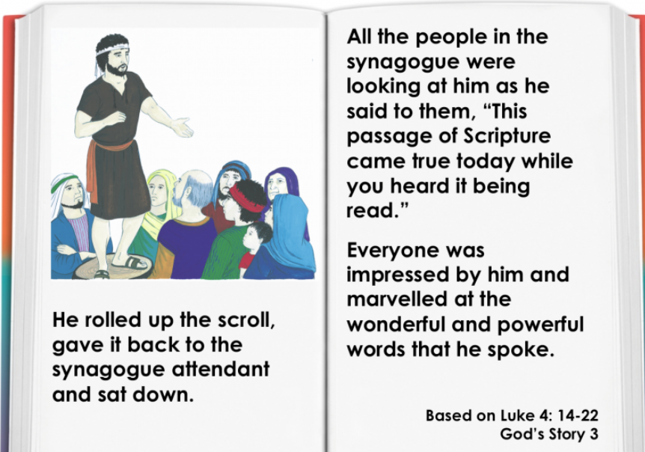

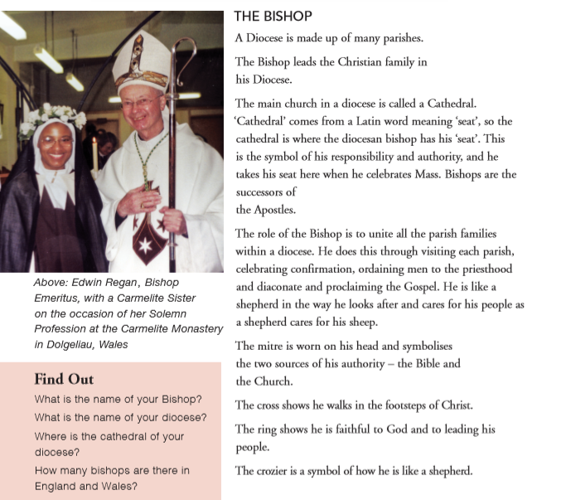
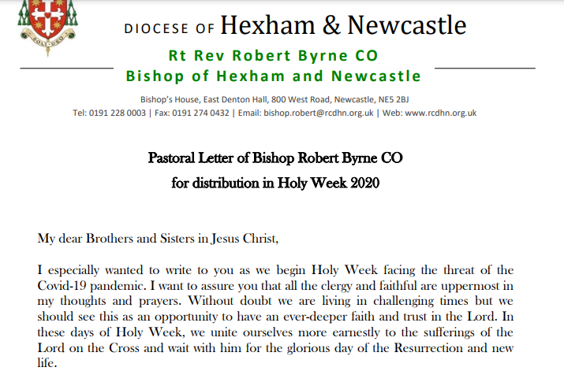

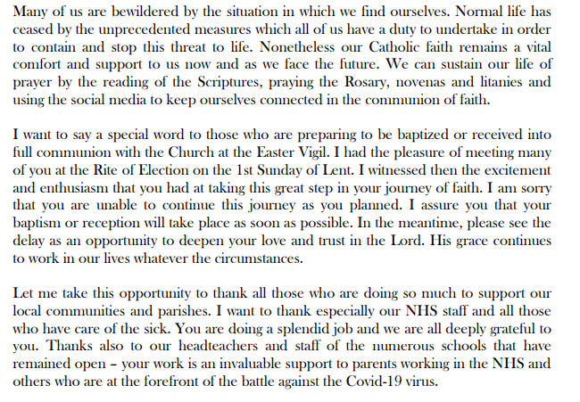

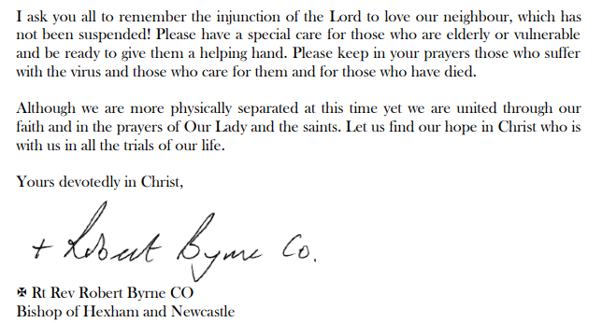

Week 3
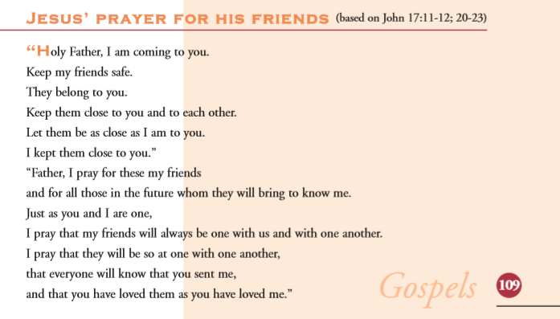
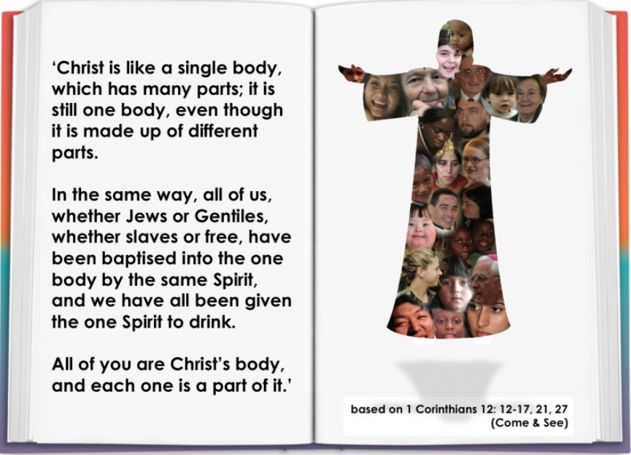

Week 4

Act of Worship
MISSION
Year 5

Gathering
Together
You might like to set up a Focus table with some of the following:
a cloth, a candle, an image of Christ and his apostles (from the internet),
a Bible, if possible (opened at Luke 4:14-22)
(You might like to play some quiet music to create a reflective atmosphere)
We gather In the name of the Father and of the Son and of the Holy Spirit Amen.
We will first light a candle to show that Jesus, whom Christians call, ‘the light of the world’ is with us in a special way. At this time of year, during this season, we are very aware that we need light in the darkness.
We have been finding out about the mission of Jesus and how he called others, like the Apostles, to follow him. We know that the mission of Jesus continues today and that our Bishop Robert looks after our diocese of Hexham and Newcastle, following the example of Jesus the Good Shepherd.
Quietly, in your hearts, thank God for all Church leaders and the work they do leading Christians towards God and towards unity.
The Word of God
We’re going to hear a story now told by Luke about the time when many people began to realise that there was something special about Jesus.
A reading from the Holy Gospel according to St Luke
Glory to you, Lord.
Jesus, filled with the Holy Spirit, returned to Galilee. News about him spread all through that place. He came to Nazareth where he had been brought up and went into the synagogue as he usually did. He stood up to read. He was given a scroll of the prophet Isaiah. He unrolled the scroll and found the place where it is written:
“The Spirit of the Lord is upon me for he has chosen me to bring good news to the poor, to heal the broken hearted… He has sent me to free those who are oppressed in any way.”
He rolled up the scroll, gave it back to the scroll-keeper and sat down. All the people in the synagogue were looking at him as he said:
“These words are coming true today while you are hearing them being read.”
Everyone was impressed by him and marvelled at the powerful words he spoke.

The Gospel of the Lord
Praise to you, Lord Jesus Christ

Now imagine what effect the words Jesus spoke had on the listeners… the Lord has chosen me… to bring good news… heal the broken hearted…
Think of some words that struck you in the story. This was at the beginning of Jesus’ mission, his work on earth. Can you remember something Jesus did during his ministry which made a difference to someone? (Pause)
Response to the Word

Let us remember those who carry on the work of Jesus.
We pray for our Pope Francis
that he may continue to lead the Catholic Church following the example of Peter.
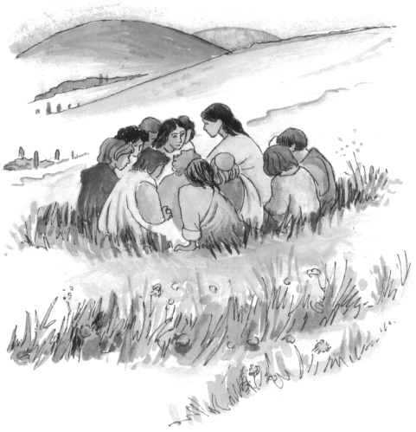
Lord hear us Lord graciously hear us.
We pray for our bishop, Robert that he may guide all our parish families.
Lord hear us Lord graciously hear us
We pray for all Christians, remembering that we are all one in Jesus Christ.
Lord hear us Lord graciously hear us.
Going Forth

Perhaps we could think of how we are called to carry on Christ’s work today.
Think for a moment of how you can live out Jesus’ mission in a simple way each day.
In the name of the Father and of the Son and of the Holy Spirit Amen.

