Background notes for parents/carers

About the theme – Local Church

After Christmas children will explore the theme of Local Church, which is our story. The parish is where people gather together to celebrate and practise care and love for each other. The diocese is the community of the Christian faithful. The Local Church theme focuses on the people of God, gathered in Christ, united in the journey of faith, in care for one another, in sharing their story and in celebration.
The experience of community is an essential and enjoyable part of life for people of every age and faith. The cycle of a year and the span of a lifetime contain occasions for regular celebrations as well as unexpected surprises, when people want to celebrate with family, friends and communities.
The Church’s celebrations are also community occasions. On Sundays, the parish family gathers together. It is a time to remember how much there is to celebrate; a time to say thank you; a time to know that God’s love is offered and made visible here and now in Jesus and in people. Sacraments are more formal special moments: signs of ‘God-with-us’, who journeys with his people; signs of strength and blessing for life.
There may be some roles carried out in the parish community which you are not familiar with so these definitions may help you explain the roles to your child:
Extraordinary Ministers of the Eucharist – a Catholic lay person who assists in the distribution of Holy Communion, either during the Mass, or afterwards, to housebound persons (ministers to the sick)
Deacon - Permanent deacons are men ordained to an office in the Catholic Church. They can be single or married and usually have secular jobs.
Transitional deacons are students in the last phase of training for the Catholic priesthood. After being a deacon for a year, they are ordained a priest by the bishop.
Deacons can baptise, witness marriages, perform funeral and burial services outside of Mass, distribute Holy Communion, proclaim the Gospel and preach the homily.

Sacristan – The sacristy is the room in church where the priest prepares for a service, and where vestments and articles of worship are kept. The sacristan organises the books needed for the church celebration. He or she lays out the vestments and anything else needed, such as cruets, chalices, ciboria, (the vessels used in Mass) linens, oils, processional crosses, candles and torches.

Greeters – meet people at the back of church as they arrive and hand out hymn and Mass books.

Catechists – someone who delivers parish education and formation programmes, for example Baptism preparation, First Holy Communion classes

Key Vocabulary | YEAR 4  Community  LOCAL CHURCH THEME  In the local church, lay people of all ages are called to undertake various roles called ministries by virtues of their Baptism and Confirmation. They help to build up the local community of the parish.  Children will know and understand  • Belonging to a community  • The life of the local Christian community  See the Background Notes for Parents and Carers  Week 1: Talk about different communities we all belong to. Read the story and ask key questions. Ask children to list workers within different communities and think about their commitment.  Week 2: Read the story ‘I have chosen you’. Ask children to learn the names of the 12 Apostles. Ask children to write a diary as if they were one of the chosen Apostles.  Week 3: Talk about the people who carry on working in the Church today and how some are called to serve their parish community. Ask children to describe their work.  Week 4: Look back at the key vocabulary and remember all that has been learnt during the topic Community.  Celebrate with a simple Act of Worship (see below).
community
commitment
responsibility
parish
laity
ministries
Extraordinary Ministers
service
ministers to the sick
readers
parish visitors
hospital visitors
Priest
deacon
flower arrangers
cleaners
sacristan
greeters
collectors
organist
catechists
Overview

Year 4
In Year 4, the children learn that each one of us belongs to several different communities. They will learn about how the parish community celebrates and different ways to serve the parish through different ministries.

Week 1: Each one of us belongs to several different communities, e.g. our family community, the school community, the area where we live etc. Think about the classroom community. What makes it work well? How does each person help make the class community a happy one? Read the story below and answer the key questions. Explain that we still belong to different communities even if we’re not allowed to meet because of Coronavirus restrictions. Look at the grid of the jobs people do in our community (see below), some may be paid, some may be as volunteers. Complete the grid with your ideas.
Week 2: At the beginning of his ministry on earth, Jesus chose certain people to follow him and share in his work. They were to be apostles and would be sent out to spread the Good News. People who followed Jesus Christ in the early Church began to be called Christians. They formed a Christian community called the Church. Read I Have Chosen You, Mark 3: 13-19 (see below). Look at the poster of Apostles and try to learn their names. Using the scripture passage, write a diary entry as if you were one of the apostles being chosen. Share what it is you were called to do and say how being chosen made you feel.
Week 3: Christians today are called, as they were in the time of Jesus, to be with him and to share in his mission. The Church has teachers and guides who, like ‘the Twelve’ in the time of Jesus, are called to be close to him, to help the whole Christian family to carry on the work of Jesus. They are called to proclaim the Good News of God’s love by what they say and what they do. In our local parish the priest guides the Christian community through leading the celebration of the Sacraments and serving the parish family – the people, families, the school, care homes and often the local hospital. Some parishes have a deacon who is ordained to care for and serve the people of the parish community.
In every parish people are needed who will help to serve others within the community in different ways. Read God’s Story 3 page 137 (below) and talk about how the people are serving their community. Talk about some of the different ministries and roles which exist to serve their local parish community for example: extraordinary ministers of Holy Communion, ministers to the sick, readers, parish visitors, hospital visitors, Priest, deacon, flower arrangers, cleaners, sacristan, greeters, collectors, organist, catechists. Try to find out what each person does (see grid below).
Week 4: Look back at the key vocabulary and remember all that has been learnt during the topic Community.
Celebrate with a simple Act of Worship (See below)
Resources
Week 1

One day a new family came to live on the estate. They had a little boy called Alfie who was deaf. Alfie went to a different school from the other children on the estate, so he did not know anyone. Jack saw him coming home from school and told Holly about him. They had not seen him at any of the activities. So, they decided to go and visit him…

The Castleford estate where Jack and Holly lived had a good community. Sister Christine who lived there was always thinking of good ideas to bring people together and help them take responsibility.
There were after school clubs to help children with homework, a rota for visiting the housebound people, a football club, a pre-school group where parents and carers could meet and talk. Sometimes, there were outings. Sister Christine organised a residents’ committee which had responsibility for running the various activities and everyone who wanted to, had a part to play. The estate was a happy place to live.

KEY QUESTIONS

- What do you think happened next in the story?
- Why was the Castleford estate a happy place to live?
- Why do you think Sister Christine helped the Castleford community?
- What do you think is meant by the word community?
- What are the advantages of being part of a community?
- What are the demands of being part of a community?
- What do you think could cause the breakdown of a community?
- What helps to build up community?

The community | The jobs people do | Commitment | Why they do it

Week 2
I Have Chosen You

- Simon (whom Jesus called Peter – the rock
- James and
- john, the sons of Zebedee (whom Jesus called sons of thunder)
- Andrew
- Philip
- Bartholomew
- Matthew
- Thomas
- James the son of Alphaeus
- Thaddaeus
- Simon the Zealot
- Judas Iscariot (who would one day betray Jesus
Based on Mark 3:13-19
Jesus left the crowds behind and went up onto the mountain. He sent for some of his friends.
When they came he chose twelve of them to be his special friends and help him in his work.
“I have chosen you to be my apostles’” he said, “I want to send you out to tell everyone the Good News of God’s love.”
These are the names of the twelve:

KEY QUESTIONS

- How do you think the apostles felt when Jesus chose them to help him in his work?
- Why do you think he chose people to help him?
- What do you think the Good News is?

Week 2 The Twelve Apostles (includes Matthias who replaced Judas Iscariot)
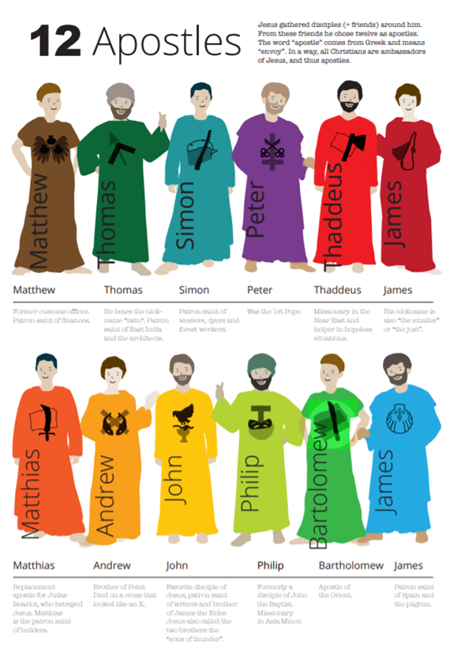

Week 3
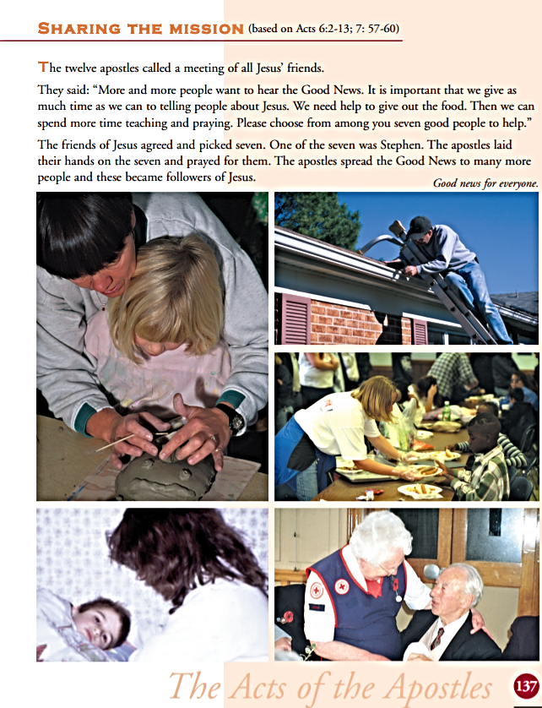

Week 3: How do different people serve the parish community?
Role or ministry | Can you describe what this person does?
readers

Priest

flower arrangers

greeters

organist

sacristan

collectors,

Extraordinary ministers of Holy Communion
(sometimes called Eucharistic Ministers)

Week 4

Act of Worship
COMMUNITY

Gathering
Together
You might like to set up a Focus table with some of the following: a cloth, a candle, a Bible, if possible (opened at St Paul’s letter to the Romans 12: 8-11), images of special people in the community eg priest, readers, Eucharistic ministers (from the internet)
You might like to create a reflective atmosphere with some quiet music
We come together In the name of the Father and of the Son and of the Holy Spirit, Amen
We will first light a candle to show that Jesus, whom Christians call, ‘the light of the world’ is with us in a special way. At this time of year, during this season, we are very aware that we need light in the darkness.
Now we have been finding out about some special people… people who help us; who are an important part of our parish community. Quietly, in your hearts, thank God for those special people.
We’re going to hear a letter from St Paul which invites us to be whole-hearted and enthusiastic members of our community.
A reading from St Paul’s letter to the Romans
The Word of God
Dear Friends
We have all been given lovely gifts. When you give, give with a loving heart. If you have a job to do, do it really well. If you are helping someone, do it happily. Be real in your love for each other. Do not just pretend to be good. Love and care for each other as good brothers and sisters. Be whole-hearted and enthusiastic in all you do. Be joyful. When things get hard, keep on going. Pray regularly. Share what you have with people in need. Always make people feel welcome.
The Word of the Lord
Thanks be to God
St Paul was writing that advice to the early Christian Church in Rome. In fact it’s still good advice for us to live by today. Members of our parish community live this out when they welcome us, when they celebrate together, when they support charities. Let us think for a moment about how we can use the special gifts we have been given to help others. (Pause)
Response to the Word

Let us pray that we can follow Paul’s words in our lives. The response is Help me, Lord
Help me to give with a loving heart and to help others happily. Help me, Lord.
Help me to love and care for others. Help me, Lord.
Help me to keep going in times of difficulty. Help me, Lord.
Help me to pray, when I am alone and as part of a community. Help me, Lord.
Perhaps we could think of how we can love and care for each other… and perhaps try to appreciate more the people who care for us in so many ways.
Going Forth

In the name of the Father and of the Son and of the Holy Spirit Amen.


