
Suggested Daily Timetable – Summer 2 Week 7
Please see a sample timetable that could be used to help with the routine of your day, this loosely follows our daily school routine.
The activities can all be changed around, and the online videos are be viewed at any time during the day.
Time | Suggested activity |  | Monday | Tuesday | Wednesday | Thursday | Friday
9:00 -9:30am | Exercise / morning walk | Go for a walk. If you have a dog, take it outside for games. If it is raining, try some yoga (yoga videos available on YouTube). Joe Wicks live P.E. sessions every weekday at 9am available on YouTube. | 5 alive - Joe wicks  LINK  Cosmic Yoga  LINK  walk | Just Dance  LINK  Cosmic Yoga  LINK  walk | 5 alive - Joe wicks  LINK  Cosmic Yoga  LINK  walk | Just Dance  LINK  Cosmic Yoga  LINK  walk | 5 alive - Joe wicks  LINK  Cosmic Yoga  LINK  walk
9:30 -10:30am | Reading / phonics activities followed by  fine motor activities | Ruth Miskin Phonics lesson available on YouTube. Reading books, phonics work on Purple mash, green and red word practice, phonic sheets, dough disco, fine motor work (Website – Class pages) | Phonics Session  RWI – LINK  Schedule attached below | Phonics Session  RWI – LINK  Schedule attached below | Phonics Session  RWI – LINK  Schedule attached below | Phonics Session  RWI – LINK  Schedule attached below | Phonics Session  RWI – LINK  Schedule attached below
10:15 – 11:15am | Play based learning / enrichment / creative time. | Inside / outside - drawing, painting, art, crafts, cooking and baking, sewing, make mud pies, writing activities, helicopter stories, role play, small world, music and building. | Free choice / play  Weekly Challenges  Purple Mash activities | Free choice / play  Weekly Challenges  Purple Mash activities | Free choice / play  Weekly Challenges  Purple Mash activities | Free choice / play  Weekly Challenges  Purple Mash activities | Free choice / play  Weekly Challenges  Purple Mash activities
11:15 – 12:15pm | Academic time  Mathematics Mastery | Online videos, School packs. Check purple mash / school website for updates. | Maths Mastery  Oak National Academy  Depth of numbers  LINK  Reception | Maths Mastery  Oak National Academy  Depth of numbers  LINK  Reception | Maths Mastery  Oak National Academy  Depth of numbers  LINK  Reception | Maths Mastery  Oak National Academy  Depth of numbers  LINK  Reception | Maths Mastery  Oak National Academy  Depth of numbers  LINK  Reception
12:15pm | Lunch
12:45pm | Chores / jobs around the house | Create a list of 12 household jobs. Roll a two dice and whatever number it makes tackle that household job first. | Chores / jobs around the house | Chores / jobs around the house | Chores / jobs around the house | Chores / jobs around the house | Chores / jobs around the house
12:45 – 1:30pm | Quiet time / story time | Reading, puzzles, nap. | Quiet time / story time | Quiet time / story time | Quiet time / story time | Quiet time / story time | Quiet time / story time
1:30 – 2:00pm | Academic time  Literacy | Online videos, school packs, reading. Check purple mash / school website for updates. | Literacy  Oak National Academy -LINK  Weekly Challenge  Purple Mash | Literacy  Oak National Academy -LINK  Weekly Challenge  Purple Mash | Literacy  Oak National Academy -LINK  Weekly Challenge  Purple Mash | Literacy  Oak National Academy -LINK  Weekly Challenge  Purple Mash | Literacy  Oak National Academy -LINK  Weekly Challenge  Purple Mash
2:00 – 3:30 | Play based learning / enrichment / creative time. | Inside / outside - drawing, painting, art, crafts (check Pinterest for craft ideas), learn to cook and bake, sew, make mud pies, writing activities, helicopter stories, role play, small world, music and building. | Free choice / play  Weekly Challenges | Free choice / play  Weekly Challenges | Free choice / play  Weekly Challenges | Free choice / play  Weekly Challenges | Free choice / play  Weekly Challenges

Read Write Inc. Phonics Timetable
https://www.ruthmiskin.com/en/find-out-more/parents/

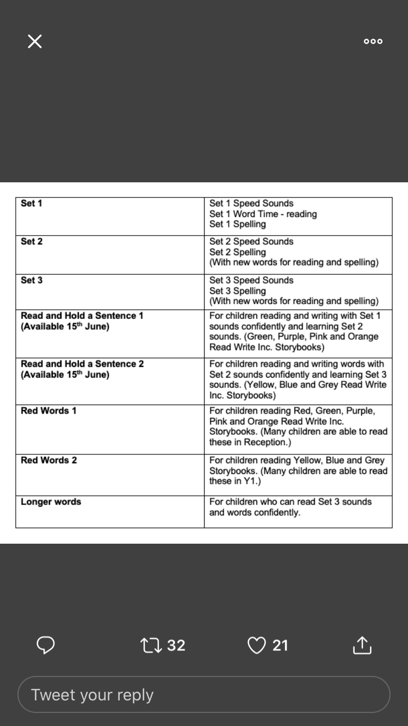
Oak National Academy

https://www.thenational.academy/online-classroom

Oak National Academy is a new collection of high-quality lessons and online resources. Backed by the Government, it has been created in response to the coronavirus lockdown.

- The Maths sessions follow our current Mathematics Mastery curriculum, they are around two weeks behind where we left off in Reception but are simple to follow and the children will be familiar with the lesson structure and layout. They use resouces you can find at home and the same terminology we use in school.

- The Literacy sessions combine FS1 (Nursery) and FS2 (Reception) but have differeciated activities avaialble for both year groups. They do not follow our current topic but offer simple literacy challenges though modelled work and are something different for your child to try .The sessions start with an easy small phonics session but you can skip this if you want. Additonal weekly literacy challenges linked to our Summer 2 topic “Oh I Do Like To Be Beside The Seasid?” will continue to be sent home as usual for you to have a go.

