Reception home learning challenges – 13/07/20
These can be done throughout the week in addition to Purple Mash, phonics and maths provided. .
Please record where possible what your child makes, learns, or discovers.
Our topic is “Oh I do like to be beside the Seaside” and this week we are thinking about the story of “The Pirates Next Door” by Jonny Duddle Link
In maths we are exploring depth of numbers within 20, please watch the National Academy –Depth of Numbers within 20- lessons this week.
Mathematics  Dice Addition -Two pirates are playing a game with dice. They roll two (or one) dice and use the number shown to  make a number sentence. Example: 6 + 6 = 12  How many different number sentences can you make? Challenge: Can you add 3 numbers together?  2 + 3 + 4 = 9  How many number sentences can you make?  Adding Machine | Communication and Language / Literacy / Understanding the World  This week we are becoming pirates. One of our challenges this week is to make your own treasure map, you will need to practice reading a map first. Can you look up your local area on a map? What can you recognise? Can you choose a place on your local map and have a go at following the map to get to your chosen destination? You could make your own map after. | Personal / Social / emotional development / Literacy/ Communication and language  This week is our last week of term and your last week in Reception. To mark then end of term and to celebrate all your hard work can you have a pirate party? Use the resources you have made for your costume. You could make some pirate food and play some pirate games. I have included some links here – party-games or pirate-party If you would like to invite your family you could write out invitations and sing some pirate shanties!
Communication and Language / Literacy  Can you make your own treasure map? You could start by hiding treasure in your house and drawing a map leading to the treasure. Remember to use the arrows to help with directions and draw the things you might pass on your way. To make your map look authentic you can stain paper with used tea bags this will make it look like an old pirate map! Remember to scrunch the paper up first and rip the corners a bit so it looks really old. Shhhhh… X marks the spot. | Literacy / Communication and Language / Personal, Social, Emotional development  Pirates Next Door  This week our story is the Pirates Next Door. Have a think of all the things you would need to become a pirate. Using the writing frame, can you draw yourself as a pirate and then have a go on your own and write the things you will need to transform yourself into a pirate. Don’t forget your clothes and what tools you might need to do your job! | Understanding the World / Communication and language  This week we are thinking all about pirates. There is lots of information we need to find out about pirates, their way of life, what they ate, how they looked and how they talked. There are also some famous pirates from history. Can you do some research all about pirates. What do you already know? What would you like to find out? Can you record your research? I have included some links below to get you started. stories-from-the-sea/pirates cbeebies/topics/pirates  uk/history/pirates/ school-radio/listen-and-play-pirates
Understanding the world / Expressive art and design  This week we are transforming into pirates. Using the list of things, you wrote that every pirate need, can you have a go at making the resources you need to transform yourself into a pirate.  You will need an eye patch, a telescope, a hat and maybe even a parrot. Have a look at the pictures below to give you some ideas! | Communication and language / Literacy  Tricky words  This week I would like you to have another go at practicing your tricky words. Listen to our tricky word songs Tricky words / Tricky words and then have a go at the tricky word game Tricky word game  When you are finished how many tricky words can you remember can you write them down? Have a go each day this week for a minute can you get faster? | Understanding the world / R.E.  Universal Church – Our World – Week 3  Using the topic planning, look at the picture of Azmera and ask the key questions. Talk about how water is a precious gift from God and we need to use it well and not waste it. Ask the children to think about all the different ways we use water at home. Ask your child to write a prayer thanking God for the gift of water and illustrate it with the different ways we use water
Physical development  This week we are training to be pirates. You will need to understand the different commands that the ship Captain will shout so you need to learn what the different commands mean. Use the table below to learn the different actions and then ask an adult to be your ship’s Captain and call out the commands! | STEM / Understanding the world  This week I have included two pirate science experiments for you to have a go at. You should be able to find most of the resources that you will need already at home. Have a go, think about what might happen, predict your answers, and then test your ideas. | Literacy / Communication and Language - P4C  Hold a P4C session with your family. Sing the song and then talk about the following P4C question –  Are pirates good or bad?  Discuss this with your family. Remember there are no wrong answers.
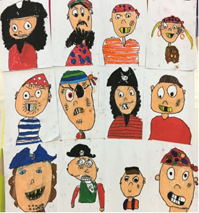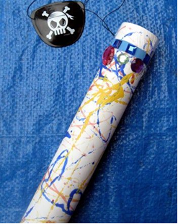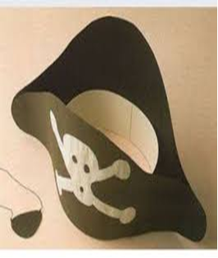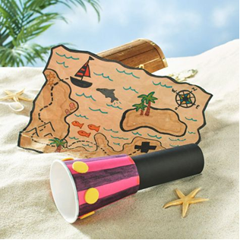
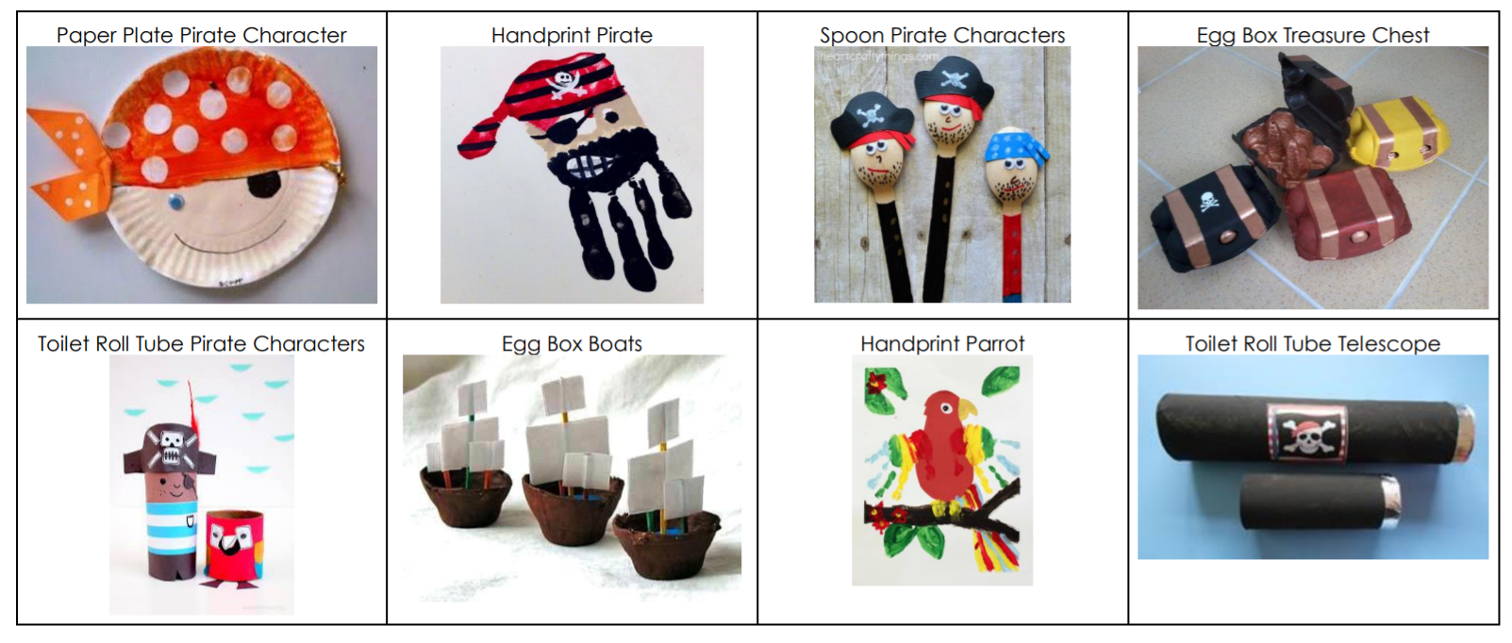
Command | Action
Man the Lifeboats | Run to a wall / line on the right side of the area.
Scrub the Decks | Crouch down and pretend to clean the floor with their hands.
Climb the Rigging | Pretend to climb a rope ladder.
Captain's Coming | Salute and shout out "Aye Aye Captain"
Admiral's Coming | Stop and salute (like captain's coming) but must continue to stand to attention until the instruction 'Admiral's gone'
Man overboard | Jump as if going over the side and then sink down holding nose with one hand and raising other hand in air as if going under water.
Walk the Plank | Walk in a perfect straight line one foot exactly in front of the other with arms outstretched to the sides (children could also walk along benches).
Boom Coming Over | Children must duck down to avoid the ships boom
Captain's Wife | Everyone curtseys
Submarines | Children lie on floor with one leg raised like a periscope
Shark Attack | Crouch with bent arm forming fin of shark
Fire the Cannon | Run and pretend to light the cannon, shout "boom!" and jump in the air.
Hit the Deck | Children lie down on their stomachs as quickly as possible.
Crow's Nest | Stand on one leg which becomes the mast, the other foot rests on that knee to become the crows nest and their torso is the pirate looking out to sea, hand above eyes!!!
Rats on board | Sit on the floor, hugging their knees, whilst feet are raised off floor.
Port | Run to left-hand side of hall
Starboard | Run to right-hand side of hall
Bow | Run to front of the room / area
Stern | Run to back of the room / area
North / South / East / West | Run in appropriate direction
Pieces of eight | Flap arms and shout "pieces of eight".
Stormy Weather | Rock from side to side.
Up on Deck! | Children have to jump on to benches. The last person left with their feet on the floor is out!
Peg Leg Jim | The children all have to walk with one leg straight and the other normally.



